p
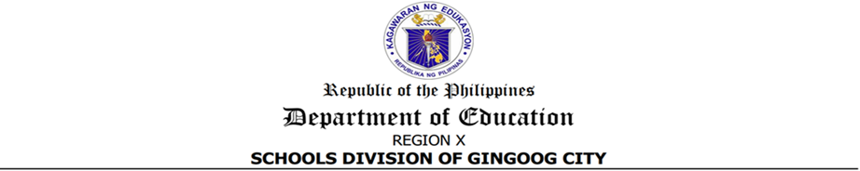



CERTIFICATE OF APPEARANCE

To whom it may concern:

This is to certify that _______________________________________________________ from __________________________________________ has appeared during the conduct of Seminar-Workshop on Writing and Conducting Innovation and Research for Non-Teaching Personnel held on November 18-20, 2024 at Eve’s Filipino Kitchen, Barangay 20, Gingoog City.

OLIVA S. SARANZA
Administrative Officer V



Website: https://gingoog.deped.gov.ph
Doc. Ref. Code | SDO-OSDS-F004 | Rev | 00
Effectivity | 06.03.2024 | Page | 1 of 1

CERTIFICATE OF APPEARANCE

To whom it may concern:

This is to certify that _______________________________________________________ from __________________________________________ has appeared during the conduct of Seminar-Workshop on Writing and Conducting Innovation and Research for Non-Teaching Personnel held on November 18-20, 2024 at Eve’s Filipino Kitchen, Barangay 20, Gingoog City.

OLIVA S. SARANZA
Administrative Officer V

Website: https://gingoog.deped.gov.ph
Doc. Ref. Code | SDO-OSDS-F008 | Rev | 00
Effectivity | 06.03.2024 | Page | 1 of 1

