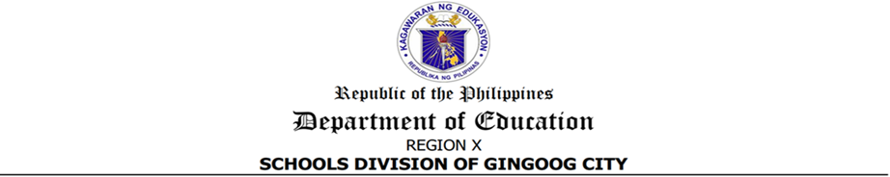
p

Certificate of Appearance
This Office certifies that Mr./Ms. __________________________________, of __________________________________, attended the 2nd Regional Management Committee (ManCom) Meeting at Noli Elementary School Bayugan City, to be hosted by the Division of Gingoog City, on May 26, 2026.

JASPER C. BUNGALON
Administrative Officer V


Website: https://gingoog.deped.gov.ph


Doc. Ref. Code | SDO-OSDS-F004 | Rev | 00
Effectivity | 06.03.2024 | Page | 1 of 1

p

Certificate of Appearance
This Office certifies that Mr./Ms. __________________________________, of __________________________________, attended the 2nd Regional Management Committee (ManCom) Meeting at Noli Elementary School Bayugan City, to be hosted by the Division of Gingoog City, on May 26, 2026.

JASPER C. BUNGALON
Administrative Officer V

Website: https://gingoog.deped.gov.ph

Doc. Ref. Code | SDO-OSDS-F004 | Rev | 00
Effectivity | 06.03.2024 | Page | 1 of 1

